NWDA Jr/Yr Clinic at Bayfield County Fairgrounds
May 20-21, 2023 (dressage and jumping)
Clinician – Rachel Wolf
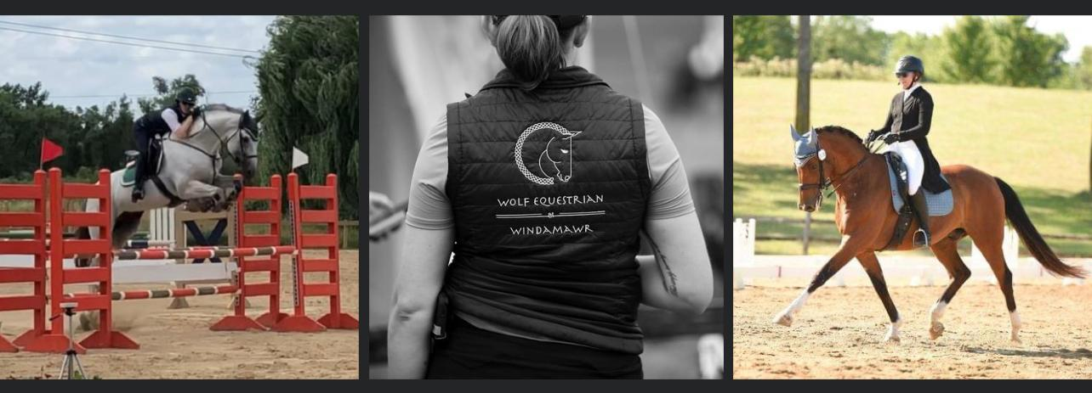
Rachel Wolf, Head Trainer of Wolf Equestrian @ Windamawr, has built a program in the West Metro area of the Twin Cities with strong fundamentals focusing on Classical Dressage and Show Jumping as well as equine and human biomechanics. Her 28 year riding career has taken her to many places which gave her the ability to learn and grow from many trainers in the US and abroad: Max Von Blucher, Jim Graham, Alan Vallencourt and Allison Sader Larson in the US. With a husband serving the Army, Rachel had the opportunity to learn and train in Germany with many international educators such as Rico Lorengel, Hans Jorg Radandt and many others. This gives her yet another perspective when working with her students and their horses as well as her other passion in breeding and training warmblood sport horses. After spending time in Kentucky showing, training clients and their horses as well as rescuing and retraining OTTBs, she has come full circle back to her home state. The fuel to her passion lies in helping her clients to achieve their goals – training at home and preparing for the show ring as well as importing new partners for her clients to go to the next level on.
Contact Jen Hovde for more information: 218-349-9753 / mackie_k_shadow@hotmail.com
Jr/Yr NWDA Member (one day session) - $210 or (two day clinic) - $310
Adult NWDA member (one day session) - $220 or (two day clinic) - $320
NWDA NonMember fee - $50 // Stall – (Day - $35 or Weekend - $60) // Bedding - $9 per bag
*The clinic will accept Jr/Yr first, then if space is available, the clinic will be open to adults.

